Note Installation for mongo db +play+npm+node+scala

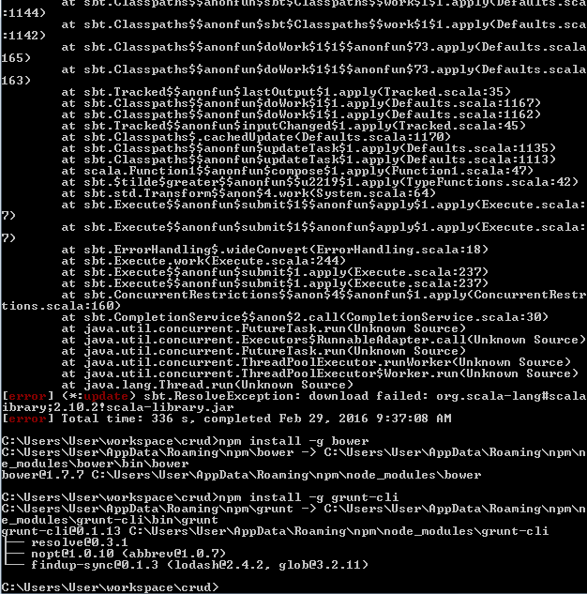

Download latest play activator from

<https://www.playframework.com/>

Take folder in your own directory and let’s start the project with this command:

Activator new

Activator run on project which have been created.